Manuel Broco Testing Requirement 10/28/2019

1. Modular test on the socket connection

a. Bidirectional communication between the server and client (single connection)

As shown below this test shows only input coming in from the client worker thread and not from attempts from the user input inside the server:

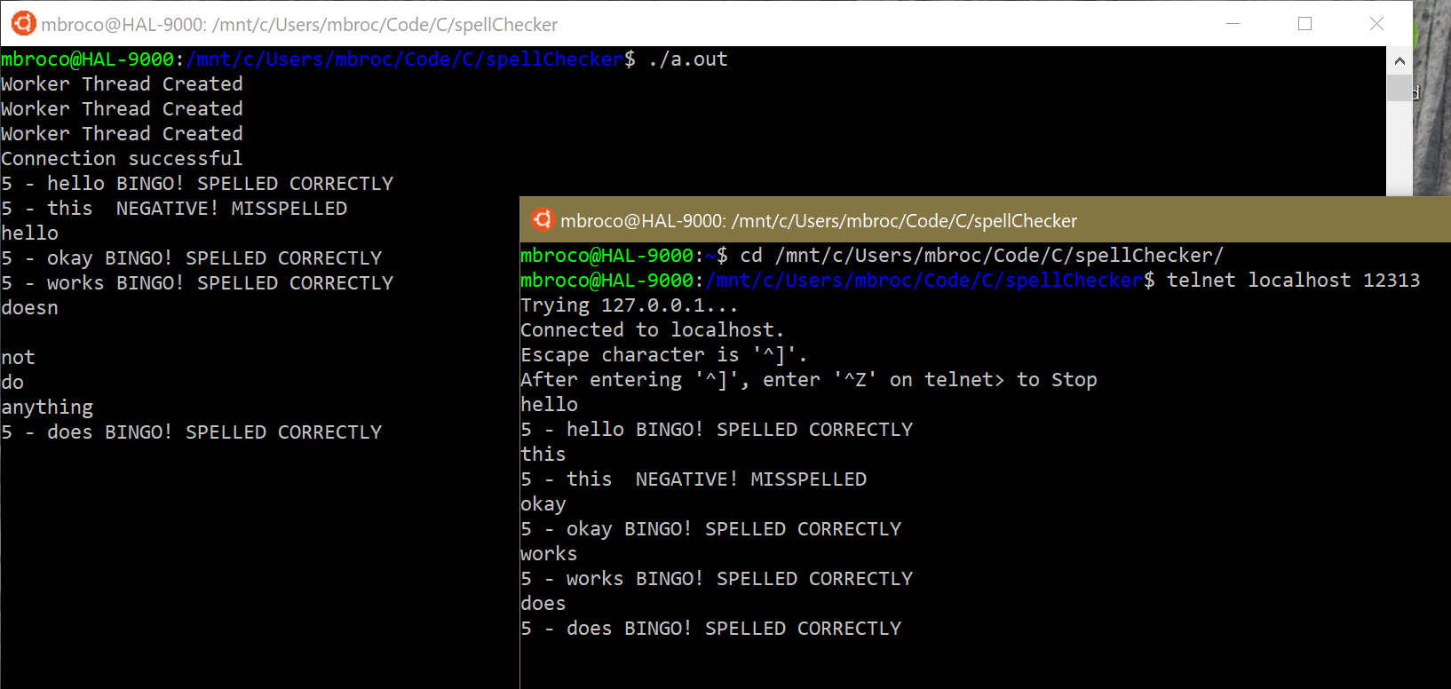

As shown below this connection is Bidirectional. Tested by closing connection from server, closes the connection to all the worker threads:

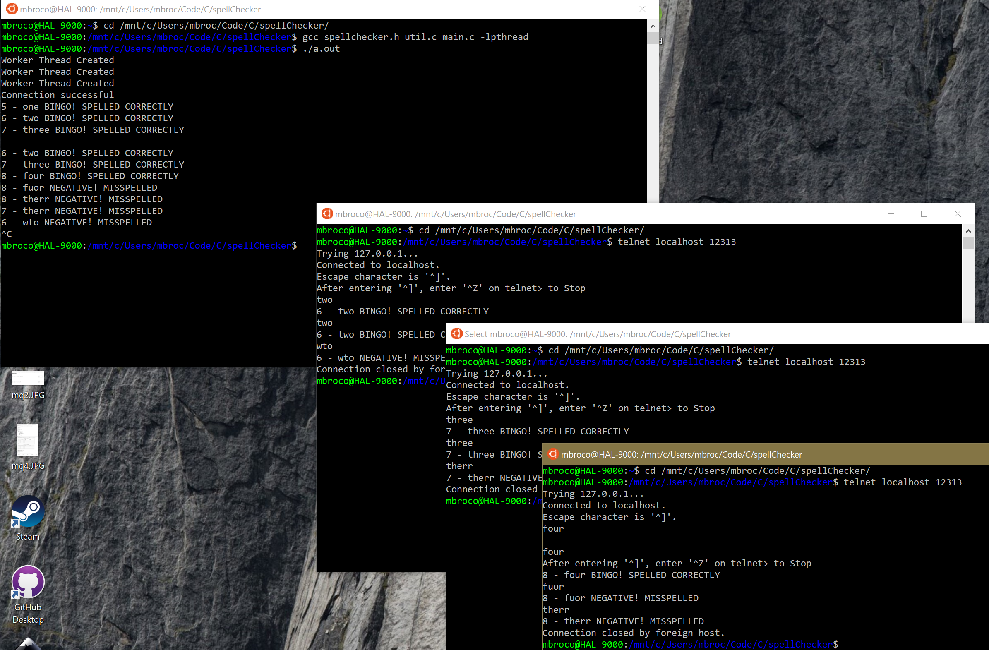

b. Keep record using screenshots of the output from server and client

2. Modular test on new thread creation

a. Create a given number of new threads

I set my max number of workers to 3.

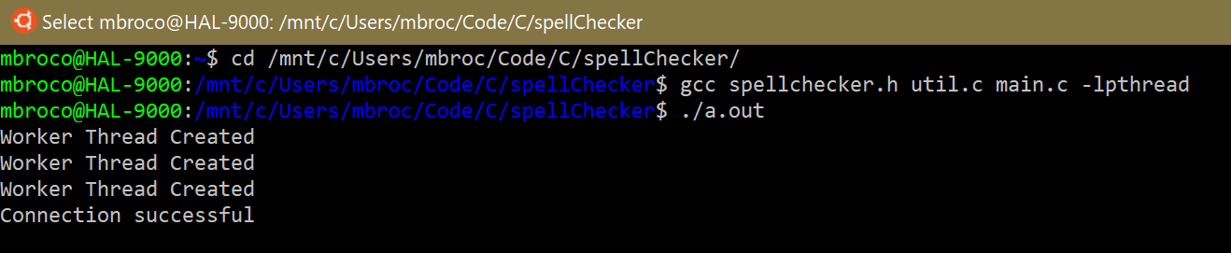

b. Print a line of prompt in each thread

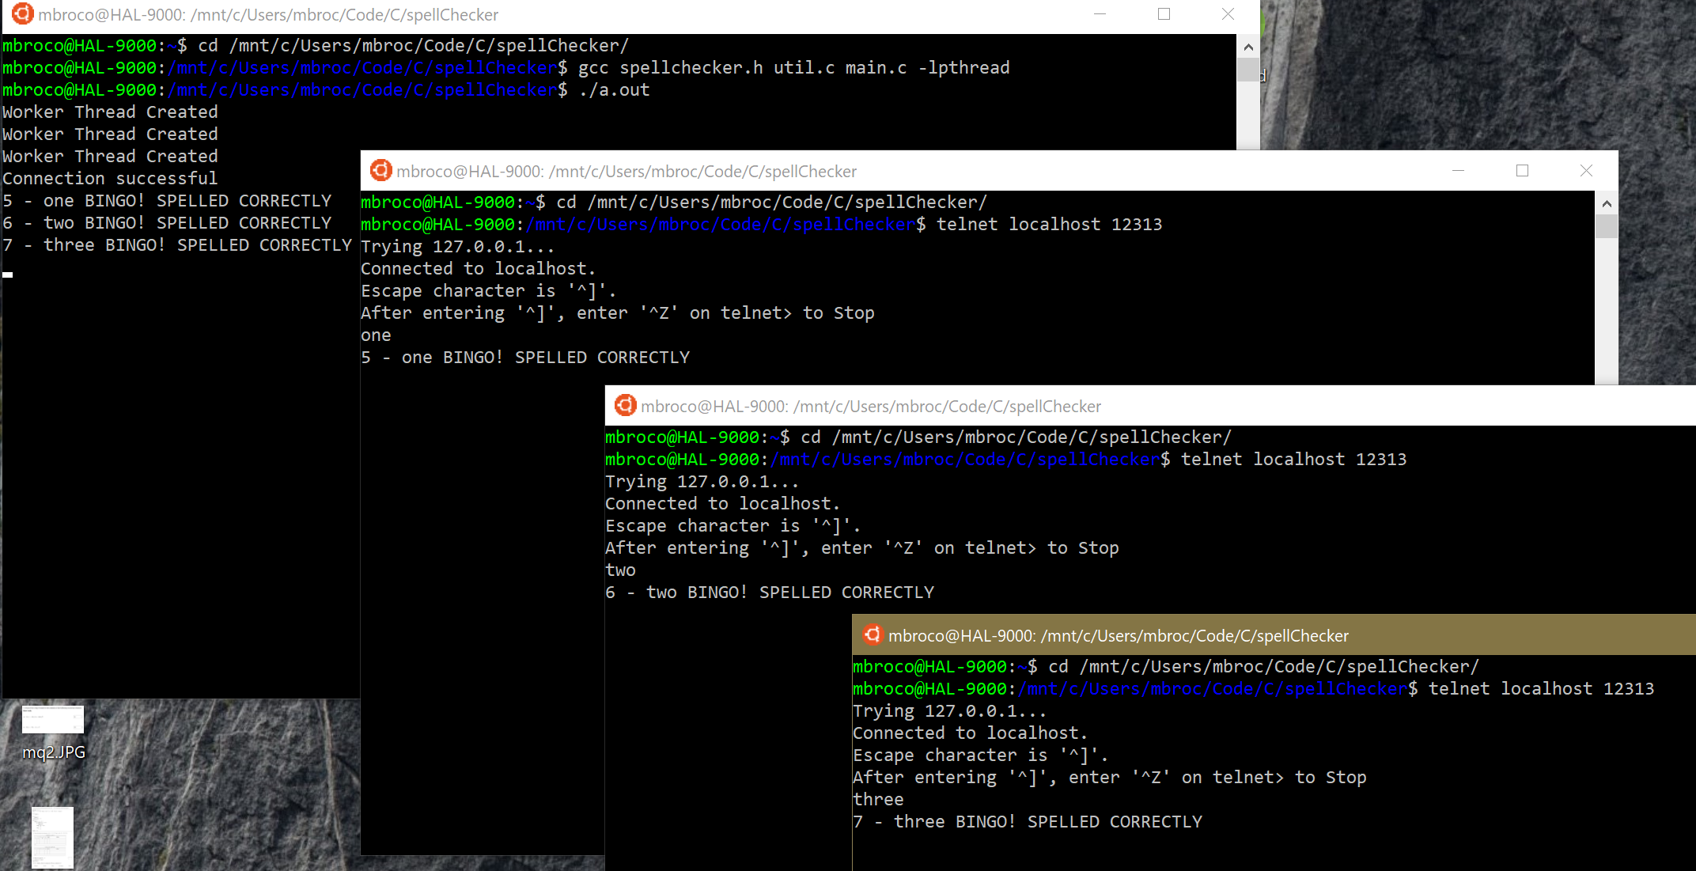

3. Modular test on the enqueue and dequeue from the shared buffer

a. Try to insert items when the buffer is full:

As shown I have top left my server running / accepting worker input. The next 3 terminals are my worker threads sending request to spellcheck certain words all successfully receiving replies as shown on both the worker thread and on the server. At the very bottom right is a fourth, unresponsive worker thread as I set my maximum number of workers to 3.

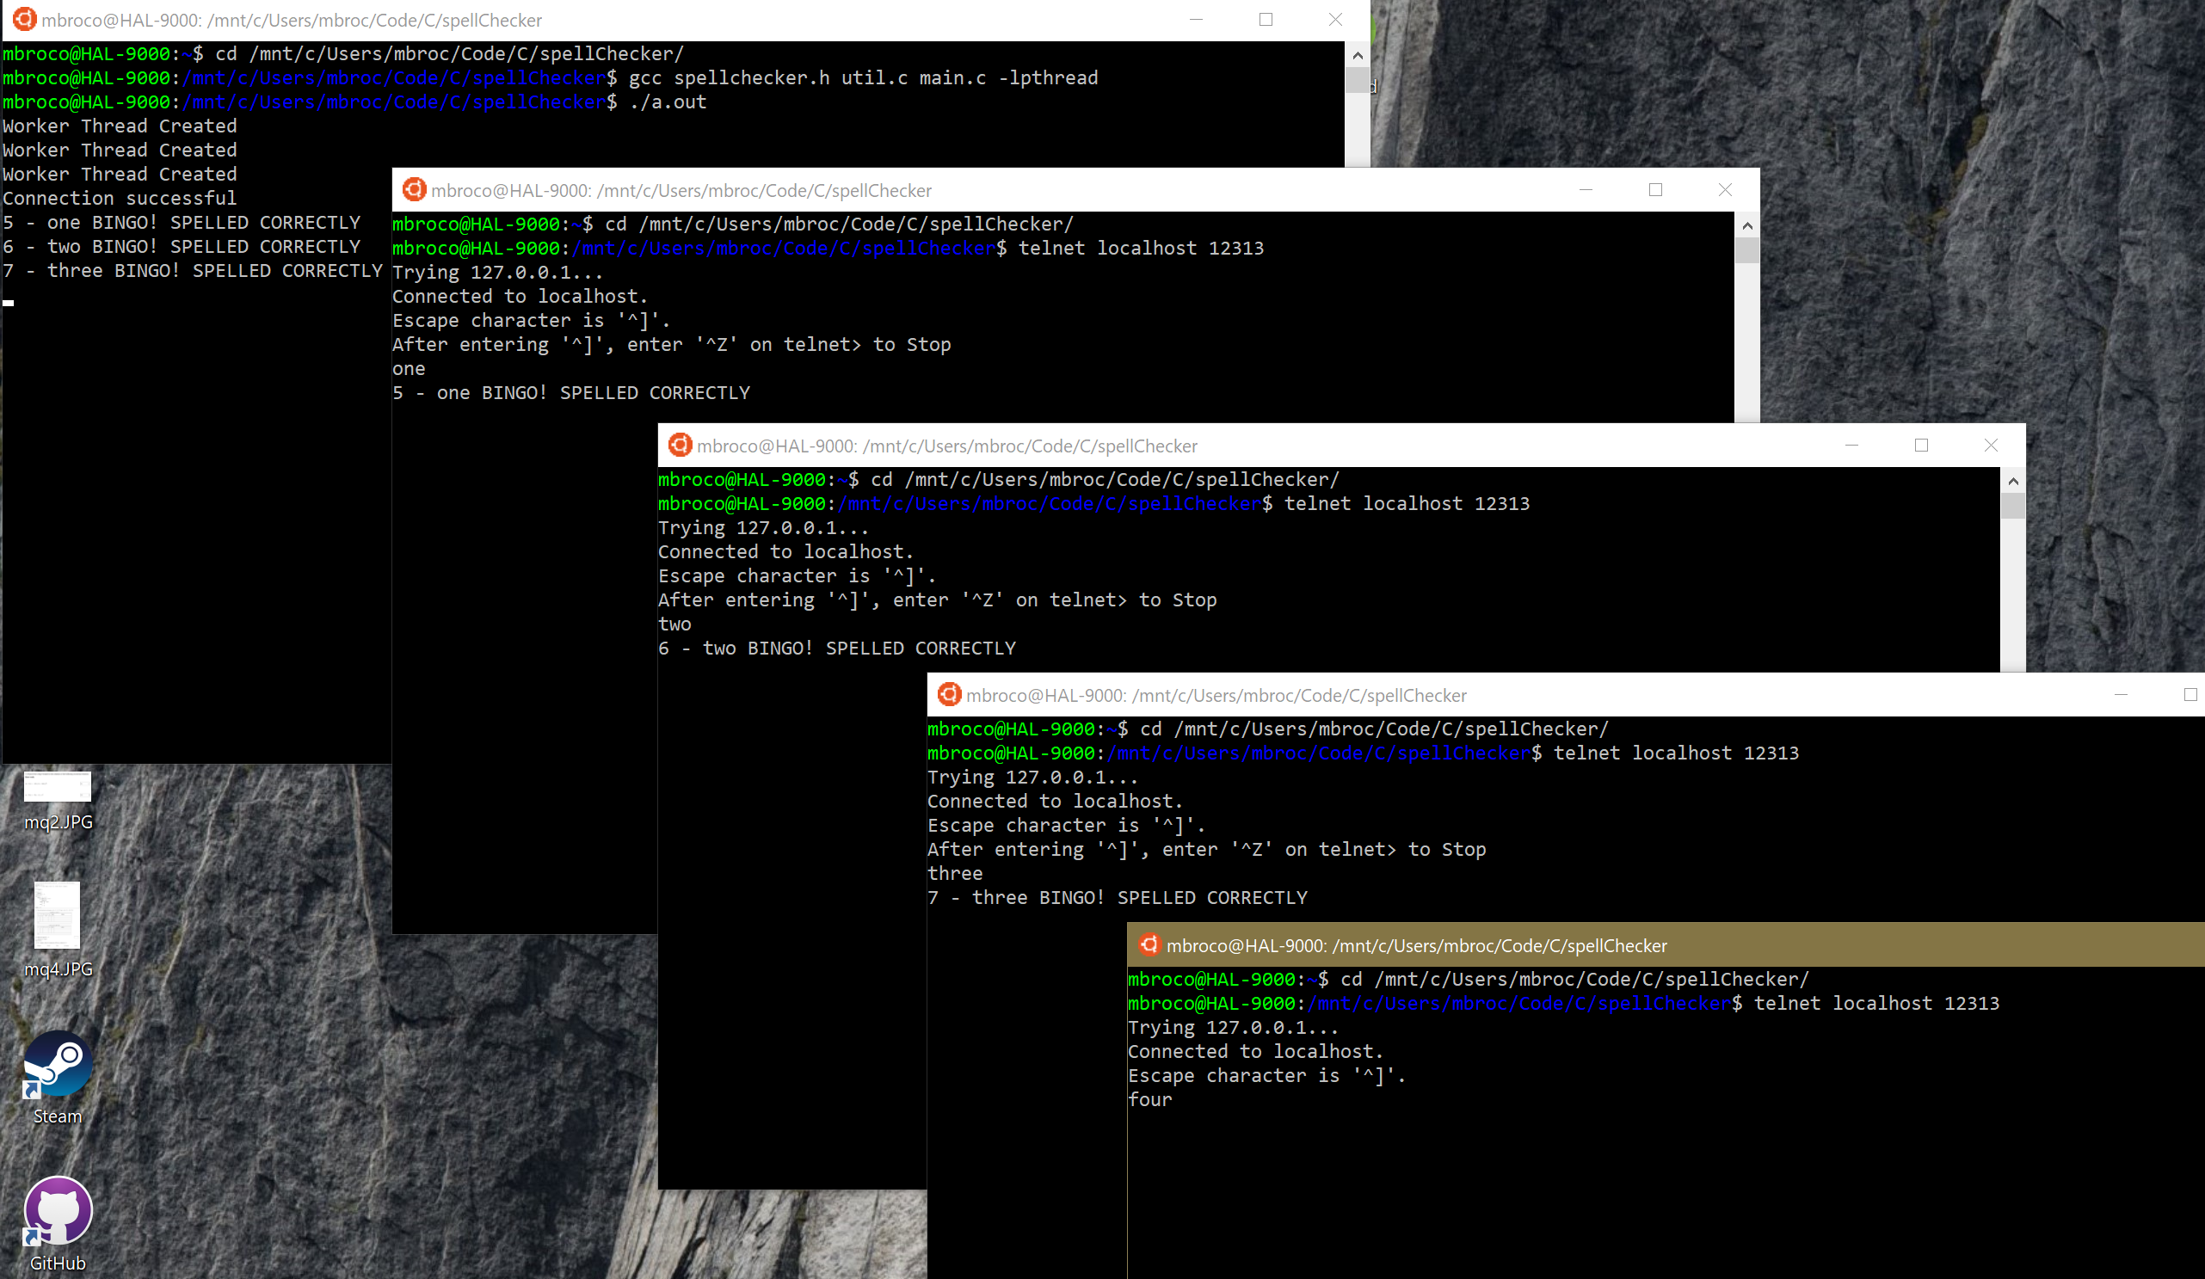

b. Try to remove items when the buffer is empty

After exiting 1 worker (number “one”), you will see number “four” get serviced:

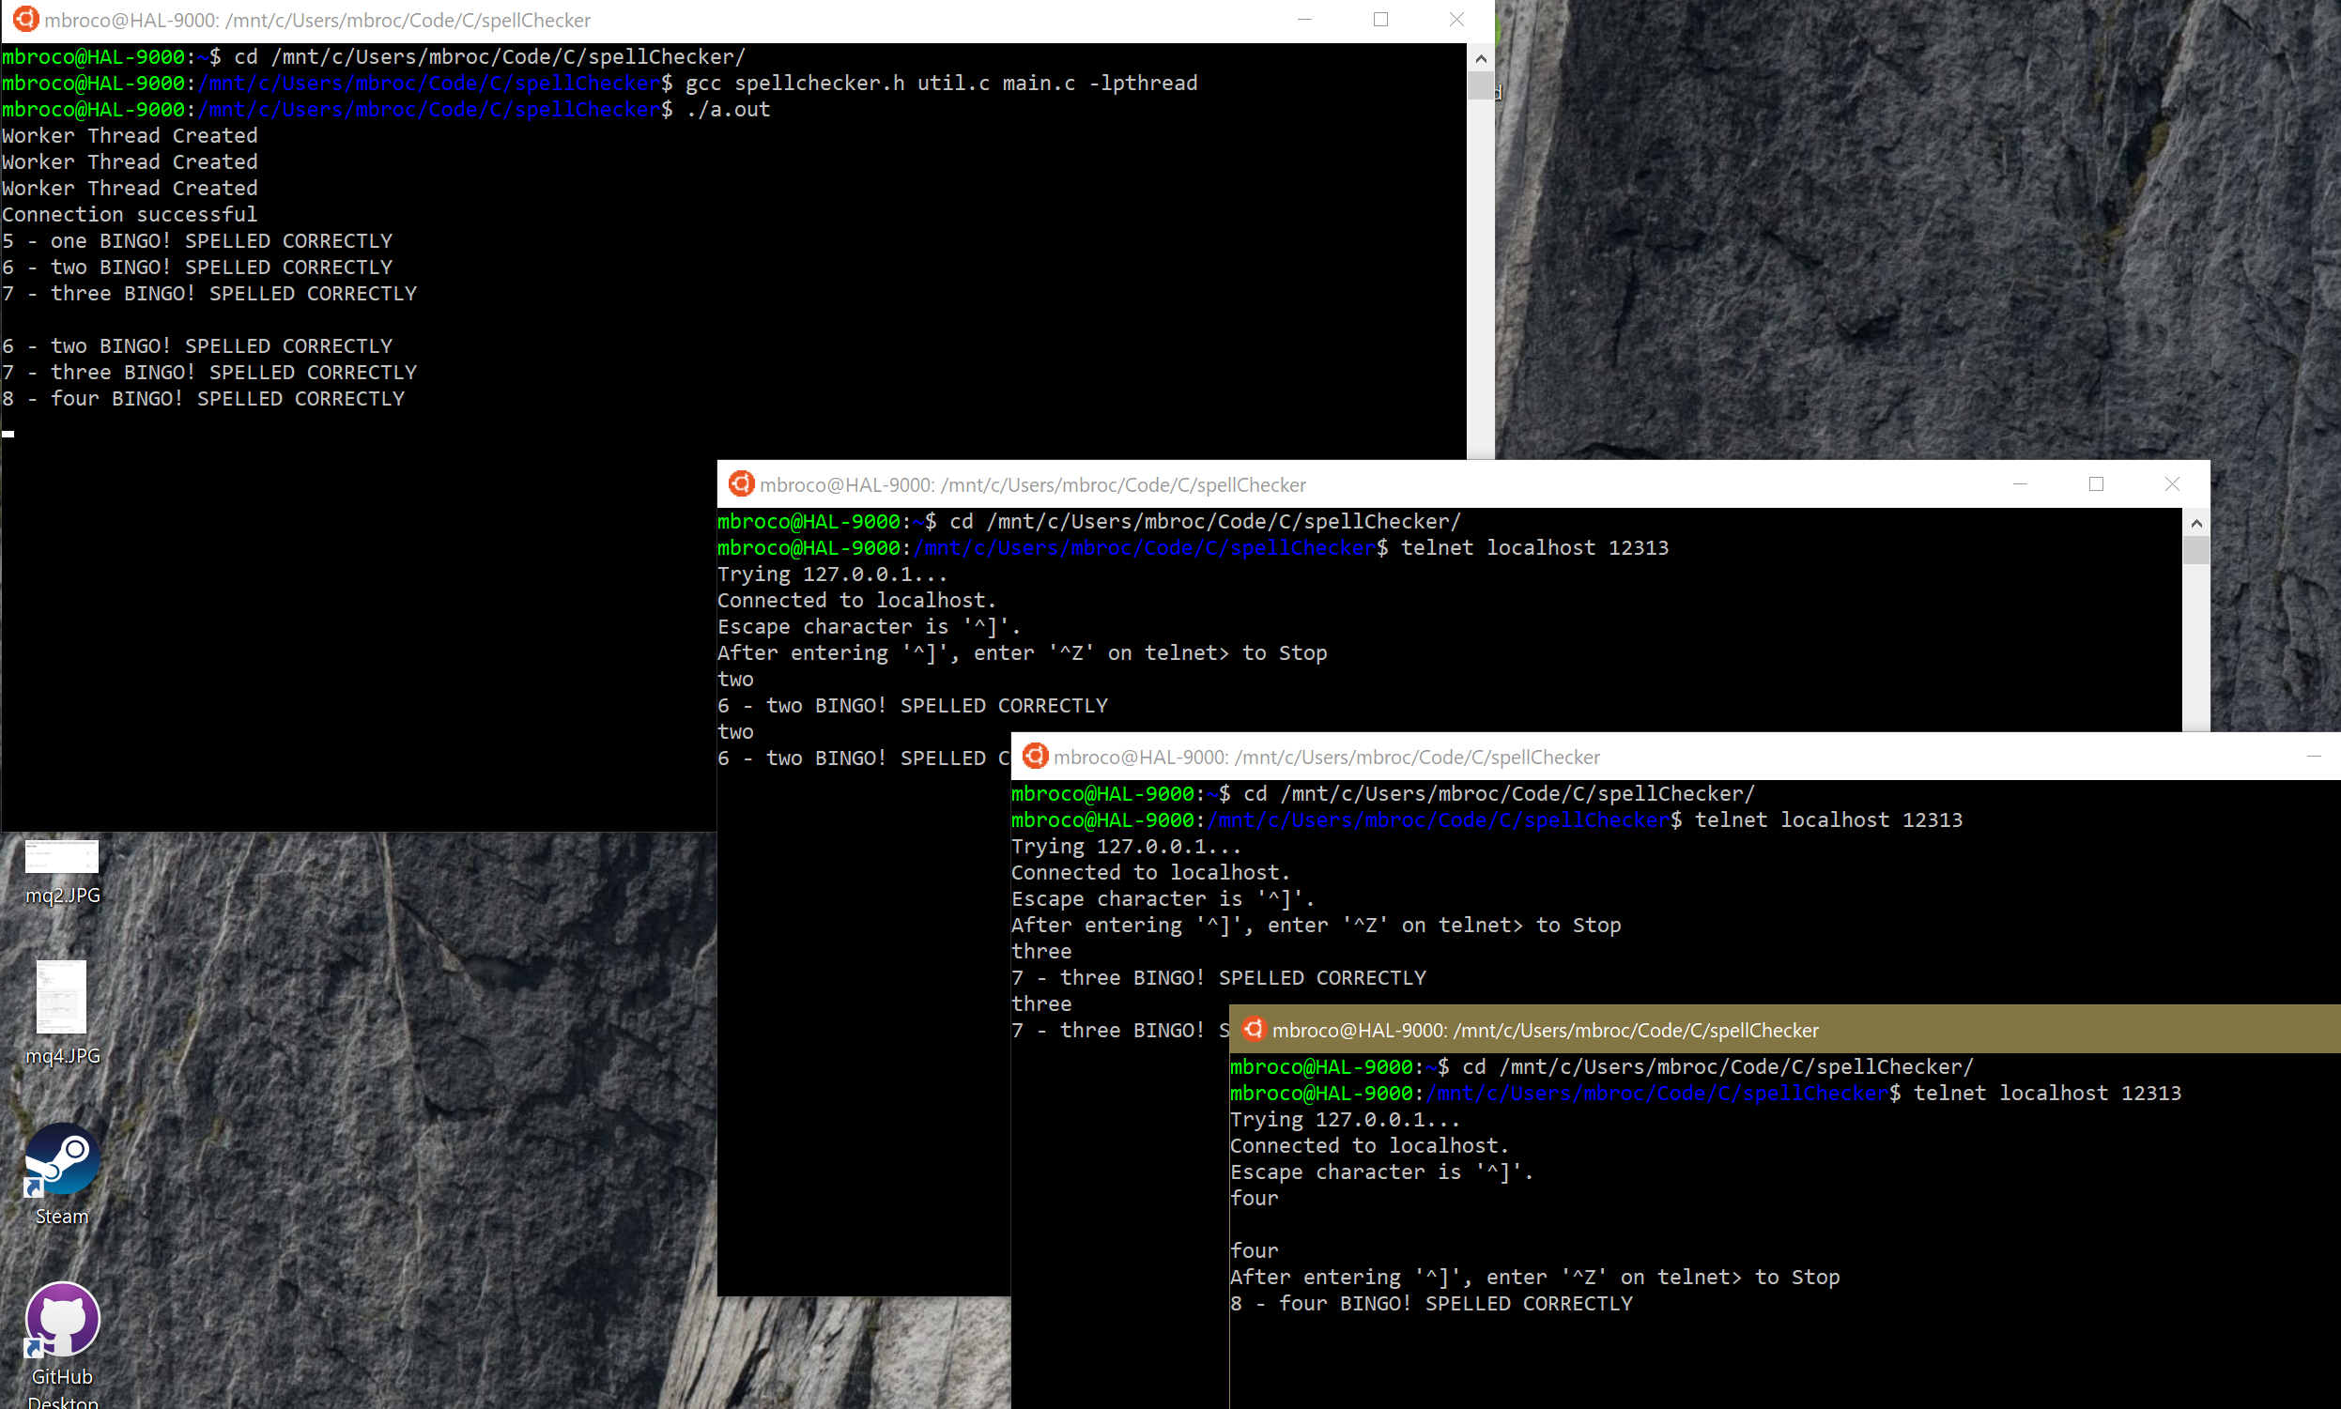

4. Modular test of **spell checking**

a. Write a local program to perform spellchecking by accepting input words from keyboard

Here I am testing my spellchecker. I start with correct spellings and misspell them in different worker threads:

